HEALTH INFORMATICS

INTRODUCTION: Health Informatics

Intersection of CS, IS, and Healthcare

Field of Information Science concerned with management of Healthcare Data through application of Technology

- Focus: effective use of biomedical data, info, knowledge

- For: problem-solving, decision-making, scientific inquiry

- Aim: improve human health

- Relevance: 30% of world’s data comes from Healthcare sector

HIERARCHY:
Data | Observations or Facts | 12145, 78
Information | Data with meaning | Patient ID, Lung issue
Knowledge | Justifiably true | Smoking cause cancer
Wisdom | Use of knowledge to make decisions | Coal worker lung issue isn’t due to smoking

1) a)

Analyse the importance of healthcare data in improving patient care and healthcare management.

Brief Historical Context:

Analog Systems: Healthcare relied on paper records historically, which had its challenges.

Digital System: The transition to EHR led to improvement in healthcare data management

1. Evidence-based Decision Making
Healthcare data enables healthcare providers to make informed clinical decisions based on patient history.
Example: Patient with Diabetes, the records are reviewed to
- analyse symptoms
- monitor their treatment progression
- response to different medications
- make decision if further care is needed
- THUS, diagnose accurately

2. Personalized Patient Care:
Healthcare data enables tailored treatment plans that consider individual patient needs, preferences, and medical histories.
Example: Genetic testing data informs specific characteristics so personalized cancer therapies can be given.

Improved Care Coordination:
Sharing of data across healthcare providers (different hospitals)
- reduces redundant tests
- minimizes the risk of treatment errors
- thus improving the patient care

Patient Engagement:
Provides patients access to their health data.
Encourages them to actively participate in their care
They can VIEW test results, MANAGE appointments, COMMUNICATE

Public Health Monitoring:

Aggregated data allows for real-time tracking of disease outbreaks and health trends, informing public health responses (governments).
Example: Monitoring flu infection rates enables timely allocation of vaccines and resources during the outbreak.

Predictive Analytics for Disease Prevention:
ML models analyse data to identify patterns and predict diseases.
Using healthcare data, predictive analytics is possible, which facilitates early interventions.

Operational Efficiency:
Data analytics optimize operations, including:
- resource allocation,
- staffing,
- patient flow management.
Example: Analysing patient admission trends helps improve service

Cost Reduction:
Effective data management will
- reduces unnecessary tests and procedures,
- leading to significant cost savings for both patients and hospital.

Research and Continuous Improvement:
Healthcare data fosters research and innovation
Enhances healthcare practices
Example: Clinical trial data analysis contributes to refining treatment protocols and developing new therapies.

Remote Monitoring:
Using data from wearable devices can help monitor chronic conditions It allows for timely interventions.

Example Covering All Points:
Consider a diabetes patient with a complex medical history.

Their healthcare data is stored in EHR.

It allows for personalized care by reviewing history.

The data is shared among doctors/hospitals, reducing redundancy. Predictive analytics can identify risk of cardiovascular diseases.
The analytics allow preventive treatment.

The data is used for efficient resource allocation during busy periods.
The data of many patients help to monitor population diabetes.
The data helps in research, leading to continuous improvement.

1) b)

Discuss the different types of healthcare data and their respective roles in healthcare systems.

Electronic Medical Records (EMR)

Digital versions of patient health information

Examples:

Patient information (Age, Weight, Blood Type,...)

Medical history (Medications, Allergies,..)

Laboratory test results

Billing information

Role:

- EMR centralizes all patient information

- It facilitates quick access to patient information

- Thus it improve the efficiency of patient care

Medical Images

Visual representations of the interior of a body

Examples: X-rays, CT scans, MRI, Ultrasounds, PET scans.

Role:

- Crucial for diagnosis and treatment planning

- Allows to visualize abnormalities and monitor disease

Histopathology

- Histology: study of microscopic tissue

- Pathology: study of disease

Study of microscopic tissue that are affected by disease

Examples: Cancerous tissue analyzed under a microscope.

Role:

Provides critical information that helps determine disease presence

Multi Omics Data

- High throughput data using omics technology

- Example: (Genomics, Transcriptomics, Proteomics, Metabolomics)

- to understand biological systems comprehensively.

Role:

- Facilitates personalized medicine through genetic sequence

- Targeted therapies

Epidemiological Data

Socio economic, Behavioural, Health data of population

Examples: Vaccination coverage statistics, Mortality rates

Role:

- Aids public health officials to understand disease trends

- Facilitates timely allocation of resources

- Helps to design health policies to control outbreaks

Time Series Data

- Data collected at successive points of time

- Dense data coming from wearable devices

Example: Heart Rate, Blood Pressure, O2 level, Glucose level

Role:

- Supports continuous monitoring of patients,

- Provides timely interventions

Handwritten Clinical Notes

- Clinical data recorded manually

- Digitized through OCR engine

Examples: Doctors’ notes, Prescription, Handwritten lab results.

Role: Provides nuanced observations and details that might not be reflected in standardized electronic formats.

Social Network Data

- Data derived from social networks (Twitter, Facebook, Youtube)

Examples:

- Patient group discussions,

- Posts about health, contact tracing information.

Role:

- Provides insights into social determinants of health

- Sentiment Analysis

2) a)

Explore various programs and organizations related to Health Informatics, highlighting the career opportunities available

PROGRAMS

Health informatics is a rapidly growing field.

Programs can be structured as

- degrees - certificates

- fellowships - short courses

Associate Degrees: Introductory course, fundamental concept

Undergraduate Degrees: Comprehensive course, broad range
Master’s Degrees: Advanced course, Research-oriented programs.
PhD Programs: Extensive research

Certificates and Fellowships and Short Courses:

Specialized training that enhance the skills

ORGANIZATIONS
Several organizations support the field of health informatics.

Providing resources, networking, career development opportunities.
American Medical Informatics Association (AMIA)
- Serves over 4,000 members

- Offers courses, certification, career center

- Annual Symposiums to promote knowledge sharing

International Medical Informatics Association (IMIA)
- Supports international collaboration

- Represents national informatics societies worldwide
- Organizes the triennial World Congress on Health Informatics
- Provides journals

Indian Medical Informatics Association (IMIA)

National e-Health

Healthcare Information and Management Systems Society (HIMSS)
- Large organization with 50,000 members

- Focused on advancing health information technology.
- Hosts an annual symposium, provides educational resources

American Health Information Management Association (AHIMA)
- 67,000 members
- Offers certifications, educational resources, annual symposiums

Alliance for Nursing Informatics (ANI)
- 3,000 members
- Promotes collaboration in nursing informatics practices and policies.

CAREER

Chief Medical Informatics Officer (CMIO)
- Usually a physician or nurse

- CMIO develops strategic IT plans

- Helps implement technologies

Qualifications: Master’s degree in information sciences

Nurse Informaticist (NI)
Nurses who specialize in the information technology
Qualifications: Registered Nurse (RN)

Clinician Informatician (CI)
Clinicians who bridge clinical expertise and technology

Health IT Analyst
Analyzes data to improve patient care and operational efficiencies.

Data Science Analyst

Data Science on HI data

Health Information Manager
Oversees the management of patient health information and records. Ensures accuracy, accessibility, security.

Project Manager in Health

Manages HI project’s implementation and optimization.

Health Informatics Consultant

Expertise in HI and provides private consulting service

2) b) Explain the fundamental principles of security and privacy in Health Informatics and how they are applied?

The fundamental principles of security are:

confidentiality, availability, integrity

Should be compliant with regulations such as HIPAA.

1) Confidentiality
Confidentiality ensures that sensitive data is protected from unauthorized access. EHR uses following techniques to ensure it:

Usernames and Passwords: Access is restricted to authorized individuals, requiring valid credentials.

Encryption: Data is transformed into a secure format, making it unreadable to unauthorized users.

Access Control Mechanisms: Role-based access controls ensure that only authorized personnel can view specific patient information.
2) Availability
Availability ensures that systems and data are accessible when needed at all times. To maintain availability,

Backup Generators: To provide power during outages

Continuity of Operations Planning: Strategies to maintain essential functions during unexpected disruptions, such as natural disasters.

Peripheral Equipment: Devices such as load balancers, redundant network paths are deployed to prevent downtime.

3) Integrity
Integrity ensures the trustworthiness and accuracy of data, preventing unauthorized modification or corruption. Measures:

Database Best Practices: Implementing strong validation rules

Data Loss Solutions: Regular backups and version controls are used
Archival Tools: They help preserve historical data

4) Authentication

Verifying the identity of users accessing healthcare systems.

Multi-factor authentication (MFA)

5) Authorization

Users have appropriate level of access based on their role.

Role-Based Access Control (RBAC)

- Doctor can access full patient records,

- Receptionist may only view appointment details

6) Compliance with Regulations

Adhering to legal and regulatory requirements regarding the handling of health information.

- HIPAA (Health Insurance Portability and Accountability Act)

- GDPR (General Data Protection Regulation)
Security Tools and Solutions applied in practise,

Access Control Lists (ACL): Restrict access to network resources based on user permissions, akin to physical locks on doors.

Firewalls: Act as barriers preventing unauthorized access, similar to fences protecting a property.

Intrusion Detection and Prevention Systems (IDPS): Monitor network traffic for suspicious activity, comparable to surveillance systems that observe and record behavior.

Authentication Systems: Verify the identity of users, functioning like keys granting access to secured areas.

Monitoring and Auditing Services: Track access and usage of network resources, resembling alarm systems.

3) a) Examine the challenges associated with the adoption and management of electronic health records (EHRs)

Financial Barriers:

- EHR adoption is expensive

- Significant initial costs ranging from $14,000 to $63,000

- However, benefits can offset some of these costs

Usability Issues:

- EHR software should be well-organized and intuitive

- Usability varies among different users

Loss of Productivity:

- Implementing EHRs leads to reduced productivity initially

- It is gradually improved over time

Physician Resistance:

- Lack of support from medical staff is a significant obstacle

- Physicians need to see clear benefits from EHR such as
(saving time, making money, benefiting patients)

Reduced Physician-Patient Interaction:

Concerns exist that EHR usage may detract from direct

physician-patient interaction

Workflow Changes:

- Transitioning from paper-based systems to EHRs

- Require significant workflow changes for all staff members

- It affects processes patient scheduling and chart management.

Security:
Ensuring that sensitive information is protected from unauthorized access, cyberattacks, data breaches

Compliance:
Adhering to regulations like HIPAA in the U.S.

Privacy Concerns:

EHRs raise new privacy threats which can be safeguarded by likes of audit trails and encryption.

Volume of Data:

Managing and processing the large volumes of data generated is overwhelming. Challenges in ensuring that storage solutions are scalable.

Data Accuracy and Quality:

Challenges exist in ensuring accuracy of data generated in EHR
(Incomplete Information, Errors, Inconsistencies)

Inadequate Proof of Benefit:

Some studies demonstrate EHR doesn’t improve medical quality or cost-effectiveness

3) b) Compare and Contrast (EHR) with (EMR), highlighting their key differences.

Electronic Medical Record Electronic Health Record
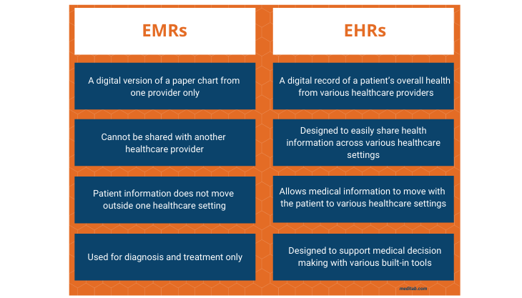

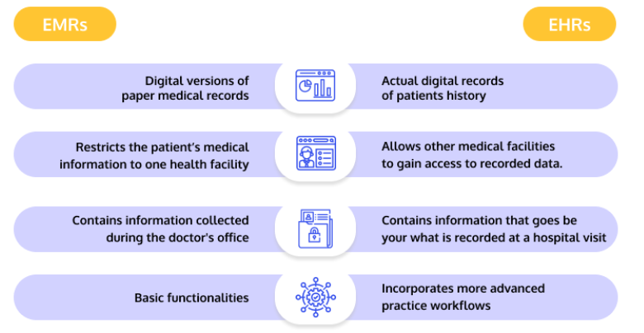

Less Expensive More Expensive

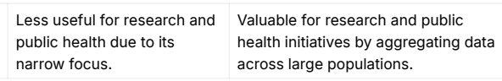

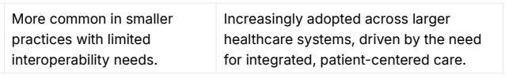

4) a) Discuss the different types of medical coding systems used in healthcare, their purposes, and how they influence billing and reimbursement.

- Medical coding is a critical component of the healthcare system

- Foundation for billing, reimbursement, maintenance of records

Process involves translating healthcare services into standardized alphanumeric codes that are universally recognized. Such as

- ICD, CPT, HCPCS, LOINC, RxNorm, SNOMED, ELINCS

1) International Classification of Diseases (ICD)

- Provides standardized descriptions of diseases

- For reporting and statistical purposes.

Current Version: ICD-10-CM

2) Current Procedural Terminology (CPT)
- Developed by the American Medical Association

- CPT codes describe medical, surgical, diagnostic services.

3) Healthcare Common Procedure Coding System (HCPCS)
This system contains both,

- Level I codes: CPT codes

- Level II codes: for billing non-physician services and supplies

(eg: medical equipment)

4) Logical Observations: Identifiers, Names and Codes (LOINC)

Standardizes codes for laboratory tests and clinical observations

5) RxNorm
- Developed by the National Library of Medicine

- RxNorm standardizes medication terminology (clinical drugs)

- Facilitates e-Prescription billing

6) Systematized Nomenclature of Medicine: Clinical Terminology (SNOMED-CT)
Provides standardized codes for a wide range of medical terms, (diseases, findings, procedures)

7) EHR-Lab Interoperability and Connectivity Standards (ELINCS)
- A lab interface standard

- Standardized messaging between labs and ambulatory EHR
- Ensures that lab results are accurately transmitted and coded

Medical coding plays a pivotal role in the reimbursement.

The codes are submitted to government payers

[Medicare, Medicaid, Arogya Yojana scheme,...]

They use the coded data to determine the amount of reimbursement to be given to the healthcare

Insurance Claims

After patient treatment, healthcare submits claim to insurance company using ICD, CPT, HCPCS codes. The insurance reviews the claim and decides the amount to be paid based on the codes

4) b) Analyze the importance of terminological standards in Health Informatics and how they enhance data accuracy and interoperability.

Terminological standards are essential in health informatics for ensuring consistency, accuracy, and interoperability in the exchange of health data. They enhance data accuracy and facilitate effective communication among various healthcare stakeholders.

Enhancing Data Accuracy

Uniform Definitions

Terminological standards provide uniform definitions

For example: standardized vocabularies like SNOMED-CT ensure that everyone uses the same terminology for diagnoses, symptoms.

Error Reduction

Consistent use of terms helps prevent misunderstandings that could lead to errors (incorrect diagnoses, inappropriate treatments,..)

By employing standardized terminologies, healthcare providers can minimize errors in data entry and clinical documentation.

Improved Clinical Decision Support

Better Decision

Facilitating Interoperability

Data Sharing and Integration

HI systems can come from different vendors.

Terminological standards enable seamless data sharing and integration by providing a common framework.

Exchange of patient data across EHR systems

Support for Health Information Exchange

It is a landscape where multiple healthcare organizations interact.

Standardized terminologies are essential for health information exchange initiatives

----

Consistent Data for Research

Terminological standards enable researchers to utilize consistent data across studies, making it easier to compare and analyze findings.

This consistency enhances the quality of research outcomes.

Facilitating Big Data Analytics

With the rise of big data in healthcare, standardized terminologies support the aggregation and analysis of vast amounts of data

Enhanced Machine Learning Applications

Standardized data allows for better training of machine learning models used in predictive analytics, personalized medicine, and automated decision-making tools. It enhances the accuracy and reliability of algorithms used and trained

LOINC

Reduces discrepancies in lab result reporting across different healthcare systems.

Enhances clarity in communication between laboratories and clinicians, improving patient care and reducing errors.

RXNORM

Facilitates accurate e-prescribing by ensuring consistent drug terminology across different systems.

Reduces medication errors by providing clear and standardized drug information, thus enhancing patient safety.

SNOMED
Provides detailed clinical information, allowing for precise documentation and better clinical decision-making.

Facilitates communication between different healthcare providers and systems, thereby improving care coordination and patient outcomes.

5) a) Discuss the key barriers to implementing Health Informatics systems in healthcare settings.

Same answer as 3) a)

5) b) Explain the security principles involved in maintaining privacy and protecting sensitive data in Health Informatics.

Same answer as 2) b)

6) b) Discuss the various career opportunities in the field of Health Informatics and the skills required for success.

Same answer as 2) a)

6) a) Explore how Health Informatics modules are used in the insurance sector to streamline processes and improve efficiency.

Health informatics modules play a vital role in the insurance sector (payers) by streamlining processes and improving efficiency.
Electronic Claims Transmission
Enables the automated submission of claims from healthcare providers to payers, reducing paperwork and processing time.
Trend Analysis through Data Analytics
Analyzes data to identify trends in claims, utilization, and patient outcomes, aiding in informed decision-making and resource allocation.

Fraud Detection and Prevention

Physician Profiling
Assesses provider performance based on quality metrics, costs, and patient outcomes to identify high-performing providers and improve overall care quality.
Information Systems for Quality Improvement Initiatives
Implements systems that track quality improvement metrics, helping insurers assess the effectiveness of care provided to members.
Monitor Adherence to Clinical Guidelines
Uses informatics to ensure that providers follow established clinical guidelines, promoting consistent and high-quality care.
Monitor Adherence to Preferred Formularies
Ensures that prescriptions align with preferred drug lists, which helps control costs and improve patient outcomes.
Promote Claims-Based Personal Health Records (PHRs)
Encourages the use of claims data to build personal health records, allowing patients to access their health information easily.

Information Exchanges
Facilitates data sharing among healthcare entities, ensuring that insurers have access to up-to-date patient information for processing claims.
Reduce Litigation through Improved Patient Safety
Enhances patient safety by reducing medication errors, which can lead to fewer malpractice claims and associated litigation.
Alerts to Reduce Test Duplication
Implements alert systems that notify providers about previously ordered tests, helping to minimize unnecessary repeat testing.
Electronic Health Records (EHRs)
Integrates EHR systems that allow insurers to access patient records, streamlining claims processing and improving care coordination.
Electronic Coding and Billing
Automates coding and billing processes to ensure accurate and timely claims submissions, reducing errors and improving revenue cycle management.
Information Systems to Monitor Outcomes
Tracks patient outcomes, length of hospital stays, and disease management to improve care quality and reduce costs.
eMARs (Electronic Medication Administration Records)
Facilitates accurate medication administration tracking, ensuring that patients receive the correct medications at the right times.
Barcoding and Radio Frequency Identification (RFID)
Uses barcoding and RFID technology to track patients, medications, and assets within healthcare facilities, enhancing operational efficiency and safety.
Wireless Technology
Supports real-time data access and communication among healthcare teams, improving workflow and responsiveness.

E-intensive Care Units (eICUs)
Utilizes remote monitoring technology to manage critically ill patients, enabling better care coordination and resource management.
Patient and Physician Portals
Provides secure online access to health information for both patients and providers, facilitating communication and enhancing engagement.

E-prescribing
Streamlines the prescribing process by allowing providers to send prescriptions electronically to pharmacies, reducing errors and improving efficiency.
Telemedicine
Expands access to care through remote consultations, enhancing convenience for patients while optimizing resource use for insurers.
Picture Archiving and Communication Systems (PACS)
Digitizes medical imaging for easy access and sharing, improving workflow for imaging services and facilitating quicker claims processing.

Health informatics modules are integral to enhancing the efficiency and effectiveness of the insurance sector by automating processes, improving data management, and fostering better communication between providers and payers. These technologies contribute to improved patient care, streamlined operations, and cost control, ultimately leading to better health outcomes and reduced operational expenses.

7) a) Identify key organizations involved in Health Informatics and their contributions to the development of the field.

Academic Organizations:

Institute of Medicine (IOM):

- Established to evaluate healthcare policies and provide feedback.
- Promotes IT infrastructure development

- Improves healthcare safety
- Advocates for a shift from handwritten data to electronic systems.
- Identified twelve IT applications to enhance healthcare quality

(Eg: EHRs, online personal health records)

Association of American Medical Colleges (AAMC):
- Advocates integrating informatics into medical education.
- Focuses on optimizing health management

- Supports continuous learning and advancing research

Public-Private Organizations:

Bridges to Excellence:
- Rewards practitioners for superior care

- Offers recognition programs with bonuses

- (Eg: Diabetes care, Cardiac care)

eHealth Initiative:
- Promotes IT use to improve quality and patient safety.
- Provides annual surveys and articles on HI technology.

Leapfrog:
- Consortium of employers seeking high-quality healthcare.
- Uses voluntary hospital reporting to compare quality and reward.

Markle Connecting For Health:
- Promotes interoperable health IT.
- Provides resources for secure health information exchange through Common Framework.

National eHealth Collaborative (NeHC):
- Replaced American Health Information Community (AHIC) in 2009.
- Focuses on HIT standards and interoperability.
- Offers NeHC University for HIT education.

Healthcare Information Technology Standards Panel (HITSP):
- Established to harmonize HIT standards.
- Provides specifications for interoperability.

Certification Commission for Healthcare Information Technology (CCHIT):
- Certifies EHRs and other health IT for interoperability and quality.
- Offers various certification levels

National Committee on Vital and Health Statistics (NCVHS):
- Advisory body to the Secretary of Health and Human Services.
- Provides expertise in health statistics, data standards, and electronic health information exchange.

US Federal Government:

Medicare/Medicaid, Veterans Health Administration,:
- Major funders of healthcare programs involved in HIT initiatives.
- Support for pilot projects to improve care quality and reduce costs.

American Recovery and Reinvestment Act (ARRA):
- Focuses on HIT adoption, including EHRs, training, and research.
- Goals include improving quality, engaging patients, and privacy.

Health Resources and Services Administration (HRSA):
- Supports underserved and rural populations with HIT grants.
- Promotes telemedicine

National Institute of Standards and Technology (NIST):
Provides EHR testing recommendations and guidelines for usability and standards.

State Governments and HIT:

State Alliance for e-Health:
Addresses best practices, policies, and adoption challenges for HIT.
Focuses on e-prescribing and data privacy/security.

International Governments and HIT:

Focus on cost-effective health IT solutions.
Deal with issues like IT interoperability and certification challenges.
European Union refers to health IT as eHealth and ICT (Information and Communication Technology)

7) b) Examine the limitations of Health Informatics in gaining widespread public acceptance and usage.

Privacy Concerns
Many individuals are concerned about the privacy and security of their personal health information (PHI) when stored electronically.

Fear of data breaches or unauthorized access can lead to reluctance in using health informatics systems, particularly among patients.

Lack of Interoperability
Many health information systems do not communicate effectively with each other due to varying standards and protocols.

This lack of interoperability can result in fragmented care, where patients may have multiple records across different systems, leading to confusion and dissatisfaction.

Technological Literacy
A significant portion of the population may lack the necessary technological skills to effectively use health informatics tools.

Low technological literacy can create barriers for patients, especially among older adults or individuals from underserved communities, limiting their engagement with digital health solutions.

Costs of Implementation
The high costs associated with implementing health informatics systems can deter healthcare providers, especially smaller practices, from adopting these technologies.

If providers do not adopt informatics tools, patients may have limited access to the benefits of digital health solutions.

Resistance to Change
Healthcare providers may be resistant to adopting new technologies due to established workflows and skepticism regarding the effectiveness of informatics systems.

This resistance can slow down the integration of health informatics into routine practices, diminishing its potential benefits.
Limited Awareness and Understanding
Many patients and providers may not fully understand the capabilities and benefits of health informatics.

A lack of awareness can lead to underutilization of available informatics tools, preventing the realization of their advantages.

Concerns About Data Accuracy
Users may question the accuracy and reliability of data generated and stored in health informatics systems.

Concerns about data quality can undermine trust in electronic records, deterring users from relying on digital health tools.

Complexity of Systems
Health informatics systems can be complex and may require significant training for effective use.

Complexity can lead to frustration among users, resulting in lower adoption rates and inconsistent use of available technologies.

Regulatory and Compliance Issues
Navigating the regulatory landscape related to health informatics, including HIPAA and other privacy laws, can be challenging.

Concerns over compliance can hinder organizations from implementing health informatics solutions effectively, reducing overall adoption.

Insufficient Support and Training
Healthcare organizations may not provide adequate training and support for users of health informatics systems.

Insufficient training can lead to errors, decreased user confidence, and ultimately, lower engagement with the technology.

Perceived Lack of Value
Some users may perceive that health informatics does not significantly improve patient care or outcomes.

This perception can lead to apathy or resistance to adopting digital health solutions, limiting their use.
Cultural and Demographic Barriers
Cultural attitudes towards technology and healthcare can influence acceptance and usage of health informatics.

Diverse cultural beliefs and language barriers can create disparities in access to and use of health informatics tools.

Conclusion
The limitations of health informatics in gaining widespread public acceptance and usage stem from a combination of privacy concerns, technological barriers, resistance to change, and varying levels of understanding among patients and providers. Addressing these challenges is crucial for enhancing the adoption of health informatics, ensuring that its potential benefits are realized across diverse populations and healthcare settings. Initiatives to improve education, enhance interoperability, and address privacy concerns will be essential in fostering greater acceptance and utilization of health informatics systems.

8) a) Discuss how client/server management systems help ensure the privacy and security of health information in healthcare enterprises.

Client/server management systems play a crucial role in safeguarding the privacy and security of health information in healthcare enterprises.

These systems can be implemented through traditional on-premises solutions or through modern Software as a Service (SaaS) models.

1. Controlled Access to Data
Client/server systems implement robust authentication and authorization protocols to restrict access to sensitive health information. Reduces data breaches

2. Data Encryption
Both data at rest (stored data) and data in transit (data being transmitted) can be encrypted using industry-standard protocols.

[Ensures data confidentiality]

3. Audit Trails and Monitoring
Client/server systems can maintain comprehensive logs of all access and modifications to health information.

It allows tracking who accessed what information and when, which is vital for identifying security incidents and ensuring accountability.

4. Regular Software Updates and Patching
Healthcare organizations can implement regular updates and patches for the client/server software to protect against known vulnerabilities.

Keeping the system up-to-date helps mitigate security risks associated with outdated software and strengthens overall system security.

5. Data Backup and Recovery Solutions
Client/server systems can integrate data backup solutions to ensure that health information is regularly backed up. In the event of a data loss incident, such as hardware failure or ransomware attacks, backups enables quick recovery of critical health information.

6. Physical Security Measures
Organizations can implement physical security controls, such as secure server rooms, surveillance, and access controls to protect server hardware.

7. Role-Based Access Control (RBAC)
Client/server systems can implement RBAC, which assigns access rights based on user roles within the organization.

RBAC ensures that users have access only to the information necessary for their roles, reducing the likelihood of data exposure.

8. Compliance with Regulatory Standards
Client/server systems can be designed to comply with regulations such as HIPAA, ensuring that privacy and security measures meet legal requirements.

Compliance helps organizations avoid legal penalties and reinforces trust with patients regarding the handling of their sensitive health information.

9. Integrated Security Features
Many client/server systems come with integrated security features such as firewalls, intrusion detection systems, and malware protection.

These features provide additional layers of protection against cyber threats and help ensure that health information remains secure.

10. Vendor Management and Risk Assessment
Organizations can conduct thorough vendor assessments and risk evaluations when selecting client/server solutions.

This proactive approach ensures that vendors adhere to security best practices, reducing the risk of third-party vulnerabilities.

11. User Training and Awareness Programs
Regular training sessions can be organized to educate staff about best practices for handling health information and recognizing potential security threats. Increasing user awareness helps reduce human errors and enhances the overall security posture of the organization.

12. Secure Remote Access
Implementing Virtual Private Networks (VPNs) or secure access protocols allows healthcare professionals to access health information securely from remote locations.

Conclusion
Client/server management systems are integral to ensuring the privacy and security of health information within healthcare enterprises. By implementing robust security measures such as controlled access, encryption, audit trails, and regular updates, organizations can significantly mitigate risks associated with data breaches and unauthorized access. Additionally, adherence to regulatory standards and proactive risk management strategies further strengthen the security framework, ultimately fostering trust in health informatics systems among patients and healthcare providers alike.

8) b) Identify the key Health Informatics resources that healthcare enterprises should implement to enhance operations and patient care.

To enhance operations and patient care, healthcare enterprises should implement a variety of health informatics resources

Books (Handbook of Biomedical Informatics)
Journals (Journal of the American Medical Informatics Association)
E-newsletters (iHealthBeat)
Online Resource Sites (InformaticsEducation.org)

1. Electronic Health Records (EHR) Systems

EHR systems are digital versions of patients' paper charts, containing comprehensive health information across various encounters and specialties.

Streamlined Access, Improved Care Coordination, Patient Safety

2. Health Information Exchange (HIE)

HIE facilitates the secure sharing of health information across different healthcare organizations, allowing providers to access and share patient data seamlessly.

Continuity of Care: HIE enables healthcare providers to access patients' health histories, ensuring that critical info availibility.

Reduced Duplication: By having access to comprehensive patient records, HIE minimizes redundant tests and procedures, reducing costs and improving resource utilization.

Patient Empowerment: Patients can often access their health information through HIE, fostering transparency and encouraging them to take an active role in their healthcare.

3. Clinical Decision Support Systems (CDSS)

CDSS are sophisticated computer applications designed to assist healthcare providers in making clinical decisions. They analyze patient data and provide evidence-based recommendations.

Error Prevention CDSS alerts providers to potential issues, such as allergies or contraindications, reducing the likelihood of medical errors.

Guideline Integration CDSS incorporate clinical guidelines and research, helping providers stay current with best practices and ensuring evidence-based care.

Enhanced Outcomes By supporting clinical decision-making, CDSS improve treatment accuracy and can lead to better patient outcomes through timely interventions.

4. Telehealth Platforms

Telehealth platforms enable healthcare providers to conduct remote consultations with patients through video, phone, or secure messaging.

Access to Care Telehealth breaks down geographical barriers, allowing patients in remote areas to consult with specialists without the need for travel.

Convenience Patients can receive care from the comfort of their homes, leading to increased satisfaction and reduced missed appointments.

Cost-Effectiveness Telehealth can reduce overhead costs for healthcare facilities and lower transportation expenses for patients, making healthcare more affordable.

5. Patient Portals

Patient portals are secure online platforms that enable patients to access their health information, communicate with healthcare providers, and manage their health.

Empowerment By giving patients access to lab results, medication lists, and appointment scheduling, portals empower them to take an active role in their healthcare management.

Improved Communication Secure messaging through patient portals facilitates better communication between patients and providers, reducing phone call volumes and administrative burdens.

Educational Resources Portals often include educational materials that help patients understand their conditions and treatment options, enhancing patient engagement.

6. Data Analytics Tools

Data analytics tools are software applications that analyze health data to derive insights, support decision-making, and measure performance.

Population Health Management Analytics tools enable healthcare organizations to identify trends in patient populations, allowing for targeted interventions and preventive care initiatives.Operational

Efficiency Analyzing workflows and processes helps organizations identify inefficiencies, streamline operations, and reduce costs.

Quality Improvement Data analytics provide insights into clinical performance metrics, allowing organizations to implement quality improvement initiatives based on evidence.

7. Health Informatics Workforce Training and Development

Investing in training programs for healthcare staff is essential for the effective use of Health Informatics tools and systems.

Proficiency in Technology Training ensures that healthcare professionals are skilled in using EHRs, telehealth platforms, and data analytics tools, enhancing overall productivity.

Adaptability to Change Continuous education fosters a culture of learning and adaptability, enabling staff to keep up with rapidly evolving technologies in healthcare.

Quality of Care Well-trained staff can leverage informatics tools to improve patient care, leading to better health outcomes.

8. Mobile Health (mHealth) Applications

mHealth applications are mobile tools that offer health-related services, including appointment scheduling, medication reminders, and health tracking.

Patient Engagement: mHealth apps encourage patients to actively manage their health, leading to better adherence to treatment plans and improved health outcomes.

Chronic Disease Management Apps allow patients to track their conditions and share data with providers, facilitating proactivemanagement of chronic diseases.

Accessibility Patients can access health information and services anytime and anywhere, making healthcare more convenient.

9. Interoperability Solutions

Interoperability solutions enable different health IT systems to communicate and exchange data effectively.

Improved Communication Seamless data exchange between disparate systems enhances collaboration among providers, improving the continuity of patient care.

Comprehensive Patient Records Interoperability allows for a holistic view of patient health, which is essential for accurate diagnosis and treatment.

Regulatory Compliance Many regulations require data sharing capabilities, and implementing interoperability solutions helps healthcare organizations meet these standards.

10. Artificial Intelligence (AI) and Machine Learning (ML)

AI and ML tools analyze health data to identify patterns, make predictions, and support clinical decision-making.

Enhanced Diagnostic Accuracy AI tools can analyze medical images, lab results, and clinical data to assist in diagnosing conditions more accurately and quickly.

Personalized Medicine AI-driven analytics can help tailor treatment plans to individual patients based on their unique health data and historical outcomes.

Operational Automation AI can streamline administrative processes, such as appointment scheduling and billing, freeing up staff time for patient care.

9) a) Analyze the role of authentication and identity management in protecting healthcare data and ensuring secure access.

Authentication

Authentication is the process of verifying the identity of a user or system before granting access to resources. It is crucial for securing systems and protecting sensitive data.

Ensures that only authorized individuals can access specific data or systems, providing security and legal integrity to records and actions.

Basic Authentication Methods:

Username and Password:
The most common authentication method, requiring users to provide a username and a password.

Security Level: Basic; often used in combination with other methods for enhanced security.

Two-Factor Authentication (2FA):
Involves two factors from the categories of something you know (e.g., password), something you have (e.g., OTP token), or something you are (e.g., biometrics).

Examples: Using a grid card, smart card, USB token, or OTP service alongside a password.

Single Sign-On (SSO):
Allows users to access multiple systems or applications with a single set of credentials.

Simplifies user management and improves user experience by reducing the number of login credentials needed.

Example: Google SSO for accessing various Google Apps like Gmail, Docs, and Calendar.

Smart Cards:
Portable cards with embedded chips that store and process data.
Advantages: Portability, ease of use, and the ability to store encrypted data and biometric signatures.

Issues with standardization, integration, and adoption.

Digital Signatures:
Electronic signatures used to verify the authenticity and integrity of digital records.

Legal Use: Serves as a legally binding signature for electronic documents and records.

Benefit: Ensures non-repudiation, proving that the signatory is the originator of the document.

Certificate-Based Encryption:
Uses public and private keys to encrypt and decrypt messages, ensuring that only the intended recipient can read the message.

Protects sensitive data in transit, such as patient records, and helps meet compliance requirements.

Digital Rights Management (DRM) and Information Rights Management (IRM):
Techniques for controlling access to and usage of digital content.

Limits access to data, controls how it can be used or modified, and provides audit trails for compliance and security purposes.

Biometric Authentication:
Uses physical characteristics, such as fingerprints, retinal scans, or voice imprints, for authentication.

Provides a higher level of security compared to traditional methods by verifying unique physical traits.

Requires specialized hardware and can be affected by environmental factors or changes in the user's physical condition.

Security in Cloud and SaaS:

Delivers services and data storage over the internet, often using SaaS solutions.

Security Risks: Includes issues such as data breaches, loss of control over data, and reliance on third-party providers.

Considerations: Organizations must evaluate security measures provided by cloud services and implement additional controls as necessary.

- RBAC

- Regular Auditing and Monitoring

Authentication and identity management are critical components in protecting healthcare data and ensuring secure access to information systems. By implementing robust authentication methods, organizations can effectively manage user access, safeguard sensitive patient information, and maintain compliance with regulatory standards. The choice of authentication strategies and identity management practices directly influences the overall security posture of healthcare enterprises, making it essential to prioritize these elements in any health informatics strategy.

9) b) Design a database system for a hospital with 50 beds specializing in 4 specific diseases, considering the data requirements for efficient operation.

Designing a database system for a hospital specializing in four specific diseases requires a thorough understanding of the data requirements to facilitate efficient operations. Below is a proposed database schema that outlines the essential components and relationships within the system, incorporating health informatics principles to ensure effective data management and interoperability.
1. Database Design Overview
The hospital database will be relational, consisting of multiple tables to capture various entities and their relationships. The main entities include:
Patients
Doctors
Departments
Medical Records
Appointments
Treatments
Diseases
Billing

2. Entity-Relationship Diagram (ERD)
An ERD would visually represent the entities and their relationships. For the purpose of this explanation, I’ll describe the tables and their attributes.
3. Database Tables and Attributes
1. Patients Table
PatientID (Primary Key)
FirstName
LastName
DateOfBirth
Gender
ContactNumber
Email
Address
InsuranceDetails
DateAdmitted
DischargeDate

2. Doctors Table
DoctorID (Primary Key)
FirstName
LastName
Specialization (e.g., Cardiology, Oncology, Neurology, Infectious Diseases)
ContactNumber
Email
DepartmentID (Foreign Key)

3. Departments Table
DepartmentID (Primary Key)
DepartmentName
HeadDoctorID (Foreign Key referencing Doctors)

4. MedicalRecords Table
RecordID (Primary Key)
PatientID (Foreign Key)
DoctorID (Foreign Key)
Date
DiseaseID (Foreign Key)
Symptoms
Diagnosis
TreatmentPlan

5. Appointments Table
AppointmentID (Primary Key)
PatientID (Foreign Key)
DoctorID (Foreign Key)
AppointmentDate
AppointmentTime
Status (e.g., Scheduled, Completed, Canceled)

6. Treatments Table
TreatmentID (Primary Key)
RecordID (Foreign Key referencing MedicalRecords)
TreatmentDescription
StartDate
EndDate
Dosage
Frequency

7. Diseases Table
DiseaseID (Primary Key)
DiseaseName (e.g., Diabetes, Hypertension, Cancer, Heart Disease)
Description
TreatmentProtocols (Linked to Treatments)

8. Billing Table
BillingID (Primary Key)
PatientID (Foreign Key)
Date
TotalAmount
AmountPaid
OutstandingAmount
PaymentStatus (e.g., Paid, Unpaid)

4. Relationships
Patients to MedicalRecords: One-to-Many (One patient can have multiple medical records)
Doctors to MedicalRecords: One-to-Many (One doctor can manage multiple records)
Doctors to Appointments: One-to-Many (One doctor can have multiple appointments)
Patients to Appointments: One-to-Many (One patient can have multiple appointments)
MedicalRecords to Treatments: One-to-Many (One record can have multiple treatments)
Diseases to MedicalRecords: One-to-Many (One disease can appear in multiple medical records)

5. Data Security and Privacy Considerations
Encryption: Sensitive patient information, such as medical records and billing details, should be encrypted in the database.

Access Control: Implement role-based access control (RBAC) to ensure that only authorized personnel can access specific tables or fields, complying with HIPAA regulations.

Audit Trails: Keep logs of all access and modifications to sensitive data to maintain accountability and traceability.

NOT IN QUESTION BANK

NOT IN QUESTION BANK

Warehousing (CDW)

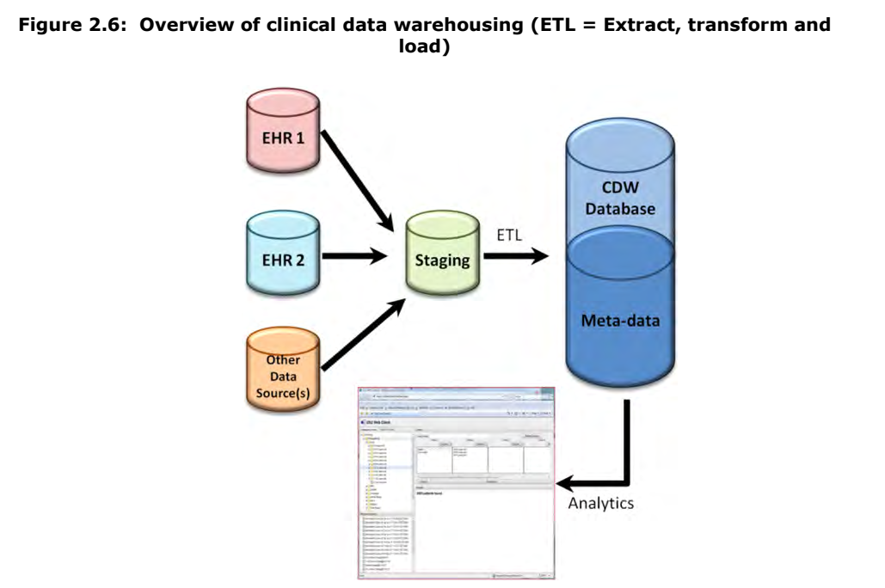

- Clinical data is collected via EHR

- Structured: Lab result (Sodium = 140mg/dl), Problem (#1 = LN)

- Unstructured: Free text

- CDW is a shared database

- Collects, Integrates, Stores clinical data

- Data from multiple sources are copied to staging database

- Cleaned and Loaded to CDW database along with meta-data

- Once in CDW, variety of analytics can be applied

- Analytics shown to user: Summary statistics

- Supports Queries

3) Standard terminologies 5 standards

HL7 (Health Level 7)

- ANSI accredited international standard

- Comprehensive framework

- Standard for exchange, integration, sharing, retrieval of EHR

- Crucial for different EHR systems to communicate effectively

Messaging Standards:

- Defines how data is formatted and transmitted between EHRs .

- Eg: HL7 v2.x used to transmit lab results, patient admissions

Clinical Document Architecture:

- Defines how data is structured and understood between EHRs.

- Eg: Clinical documents like discharge summaries, progress notes.

- Level 7 = refers to = 7th level of ISO OSI model (application level)

- Because it connects apps regardless of the underlying technology.

ICD (International Classification of Diseases)

- Managed by the World Health Organization (WHO)

- Standardizes the classification of diseases and health conditions

- Enables to code diagnoses and procedures consistently

- ICD-11 is the next eleventh revision

- ICD-10 is the current updated version

- There are over 70000 codes

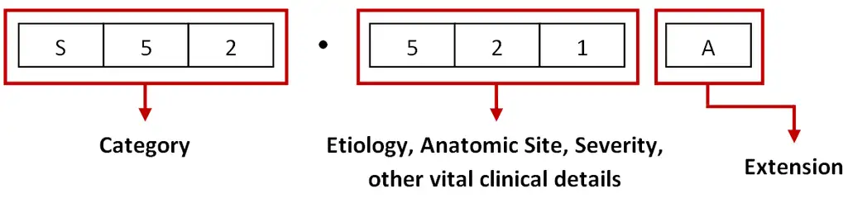

LOINC (Logical Observation Identifiers Names and Codes)

- Set of identifiers for lab tests, and clinical observation.

- Facilitates the exchange and aggregation of data

- Using standard codes, report results will be consistent

- Created by Regenstrief Institute

- Interoperable with HL7

- It is widely adopted by large commercial labs, hospitals,..

Lab Test Codes:

- Codes for various tests

- Blood glucose levels, Cholesterol level, Liver function tests,...

Clinical Measurements:

- Codes for clinical measurements,

- Blood pressure, ody mass index (BMI), Temperature.

SNOMED CT

(Systematized Nomenclature of Medicine - Clinical Terms)

- Provides comprehensive terminology

- Used to improve accuracy and consistency of clinical documentation.

- Recognized as a standard in 50 countries

- Far more concepts than ICD-10

- It covers a lot more aspects of healthcare

- Symptoms, Findings, Procedures, Situations, Substances,..

- Used hierarchical structure

- [Respiratory disorder] => Bronchitis, Asthma,...

- Maintained by SNOMED (non profit)

DICOM (Digital Imaging and Communications in Medicine)

- Standard for management of medical imaging info and related data. - DICOM is used to store, transmit, and display medical images.

- Ensures they can be viewed and analyzed across different systems.

- CT, MRI, X Ray, Radiology,

- File format in DCM instead of JPEG, BNP

Logical steps required to generate EHRs

An EHR implementation is the process of planning and carrying out the integration of EHR software in a healthcare organization

1) Design:

- Draft the roadmap

- Outline the implementation

- Outline all the processes, tasks to be executed

- Identify the individuals, committee, who will be involved

- Schedule the implementation

- Project Management protocols: GANNT chart, Calendar, Checklist

2) Recruit the Committee:

- With implementation tasks defined

- You will need people to execute each process

- Project Manager

- Developer, Tester, Consultants

- Advocates (Physician, Nurse,...)

- Beta Testers (or Users)

3) Forecast the Cost:

- Well Defined Budget

- Consider hardware, network, staff costs

- EHR requires approximately $60000 according to MedEconomics study

4) Schedule the Implementation:

- Add timescale to the roadmap

- EHR requires approximately 611 hours according to MedEconomics study

5) Migration of Patient Data:

- This is a key stage

- Conversion of PAPER records to ELECTRONIC records

- DATA Preprocessing

- DATABASE Setup

- Transfer data to new system

- Map legacy data to new system

- Testing and Verification of data of new system

6) Training Program

- Train the staff to use the EHR system

- Beta Testers

- User Usability Tests

- Role based training and Communication

- Feedback and Fix

7) Evaluation

- Deploy

- Monitor the system

(hardware, network, storage, connectivity, backups,...)

- Provide support to address any issues

- Survey, Analyse, Reports, Feedback to evaluate

